Data Dictionary

1. Immigration Table Details:

All the fields are derived from staging_immi table. Column names are self-explanatory.

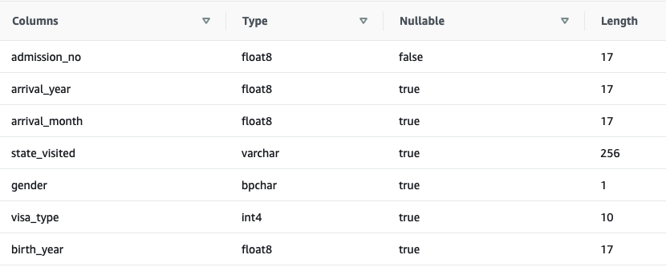

1. State Table Details:

All the fields are derived from staging_state table. Column names are self-explanatory.

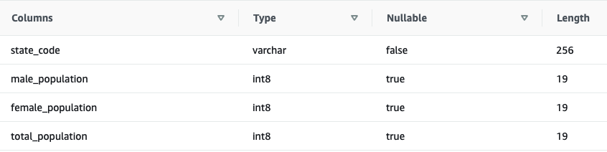

1. Arrival Table Details:

This information is derived from data stored in the immigration table.

